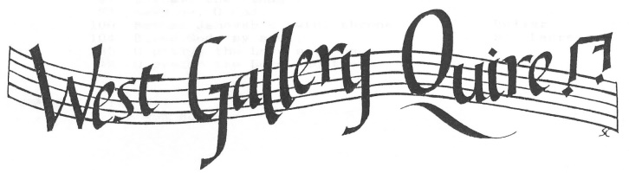

Sung in Devon
Music from our country churches in the early 1800s

Saturday June 30 2018
at the
Congregational Church, Crediton
Workshop Sessions 10.30 - 12.30 and 1.30 - 3.00
Informal Performance 3.30 - 4.30
Tea and Scones 4.30 - 5.00

This workshop’s focus is on the music written in Crediton and its surrounding area, much of it rediscovered by the Quire’s researchers. All singers and string and woodwind players are welcome. The day will include a FREE performance from 3.30 - 4.30. open to all.
The Congregational Church is towards the top of the High Street, on the right as you come from Exeter on the A377. There is a little parking in front, on a first-come-first-served basis. Please only use this if your mobility is restricted. There is a large car park up the road directly opposite the church, St Saviour’s Way. Most of the other parking in Crediton is short-term. For those with satnavs, the postcode is EX17 3LF.
The church will be open from 9.45, and there will be tea and coffee available before the first session, at lunchtime, and during tea. We are not arranging lunch as there is a variety of pubs, cafes and coffee shops around the town. You are also very welcome to bring sandwiches: the church will be kept open and staffed throughout the day.
A book of music will be available on the day for you to keep. The cost of the day will be £10.00, to be payable on arrival, and this will help to cover the cost of the book.
PLEASE BOOK BY MONDAY JUNE 18TH, using the booking form below.
………………………………………………………………………………………………………………………………………………………………..

I/We would like to reserve …… place(s) for the Crediton West Gallery Day
Full name………………………………………………………………………………………………………………………………………………..
Phone/email…………………………………………………………………………………………………………………………………………..
Voice(s) S A T B Instrument(s)
Please return to West Gallery Day, 6 East Street, Crediton, Devon, EX17 3AT

For any further information, please contact Clare Bainbridge on 01363 777220 or email at clareincrediton@gmail.com or visit creditonwestgallery.org.uk for a booking form.

